**Mild to Moderate evaluation**

Sample_ID: **NVPJKX (Cat)**

Link**:** [**https://release.animalbiome.com/pet/assessment/report/53ff99f1-dcd0-4b75-8fc0-333b1b46b848**](https://release.animalbiome.com/pet/assessment/report/53ff99f1-dcd0-4b75-8fc0-333b1b46b848)

Cats and dogs:

Any Two

(High Yellow Flag Megamonas OR (failed)

High Yellow Flag Sutterella OR (failed)

High Yellow Flag Collinsella OR (failed)

Low Yellow Flag Bacteroides OR (**passed**)

Low Yellow Flag Blautia (**passed**)

)

OR

OR Cats: 8-10 Yellow Flags (failed)

OR 5-8 Red Flags; (failed)

OR diet recommendation of increase fibre (**passed**)

OR diet recommendation of increase protein (failed)

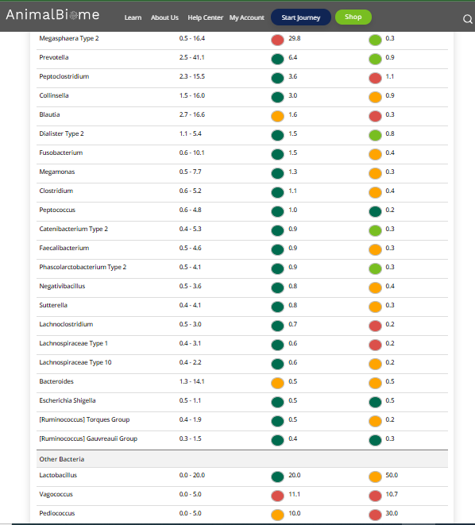



The result : **True False False True.**

Expected result : Mild to moderate

Acheived result : **passed**.

